CA 1
Build & Release Management Lab
Btech-CSE (DevOps)

Submittted by:
Nandana S
12317635
K23DV-07



- TASK 1 – PROJECT SETUP
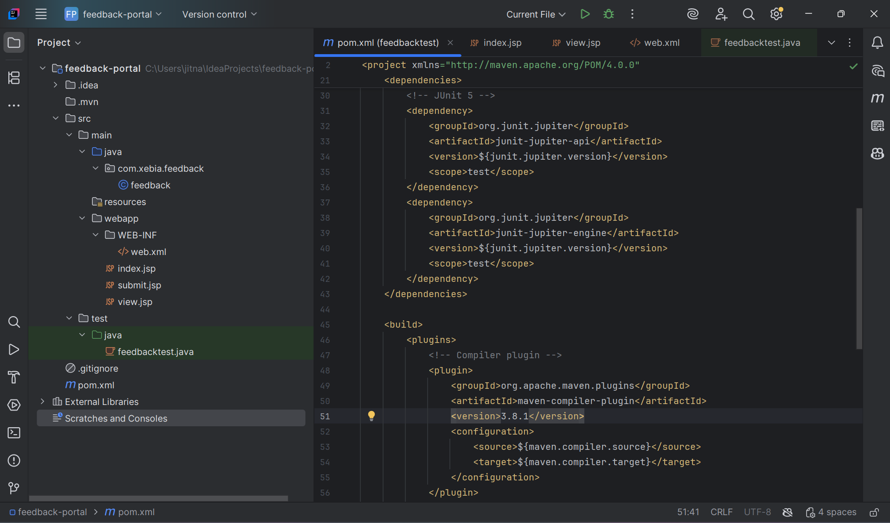
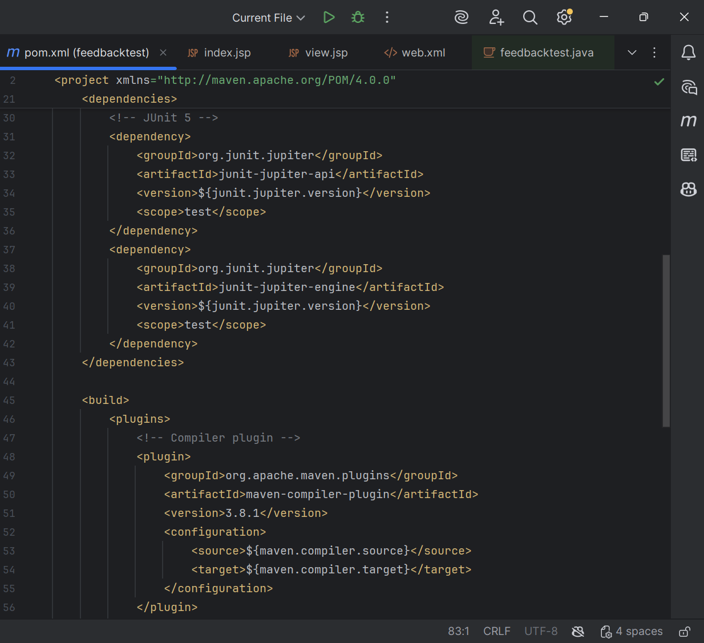
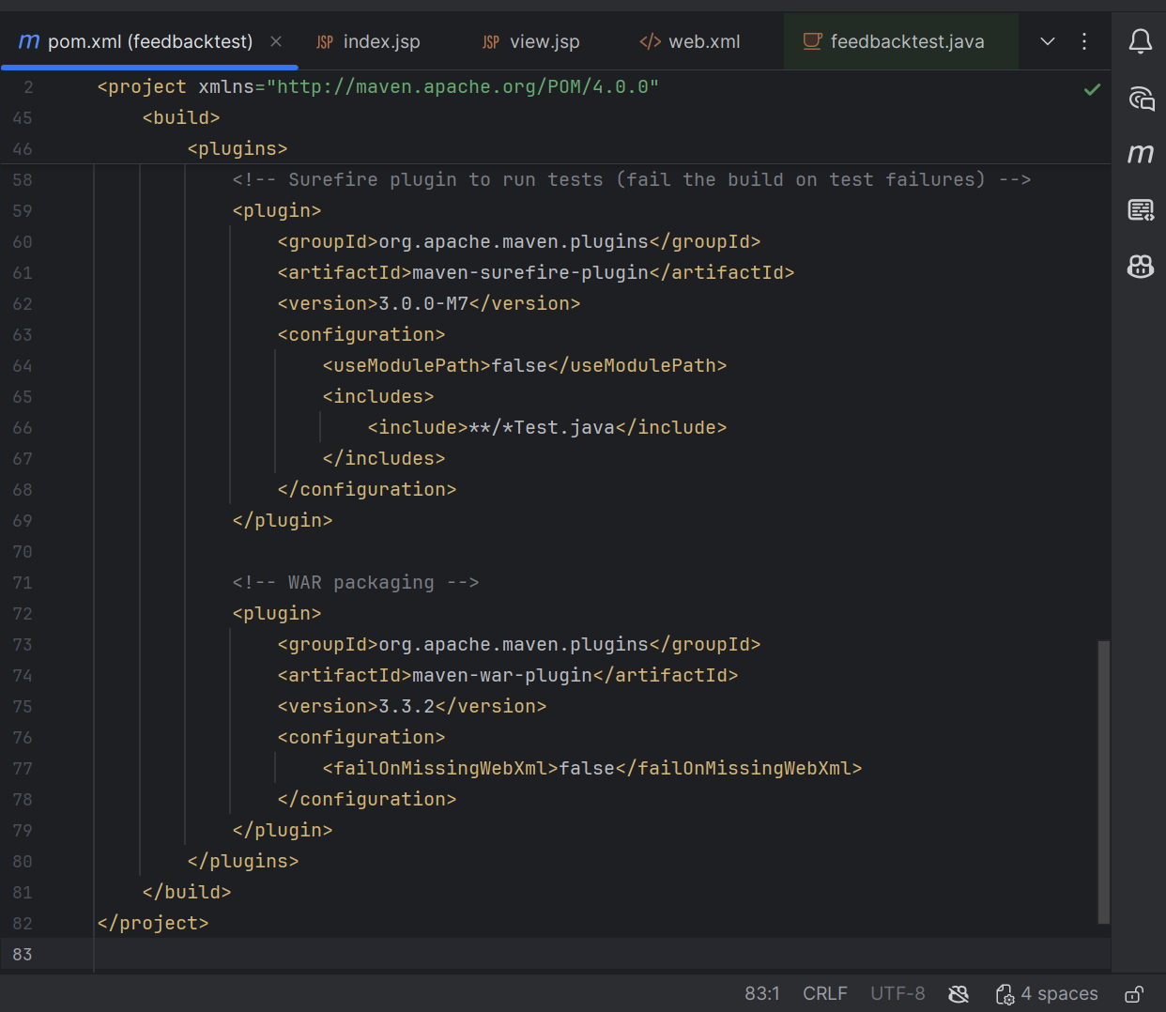

- TASK 2 – FEEDBACK LOGIC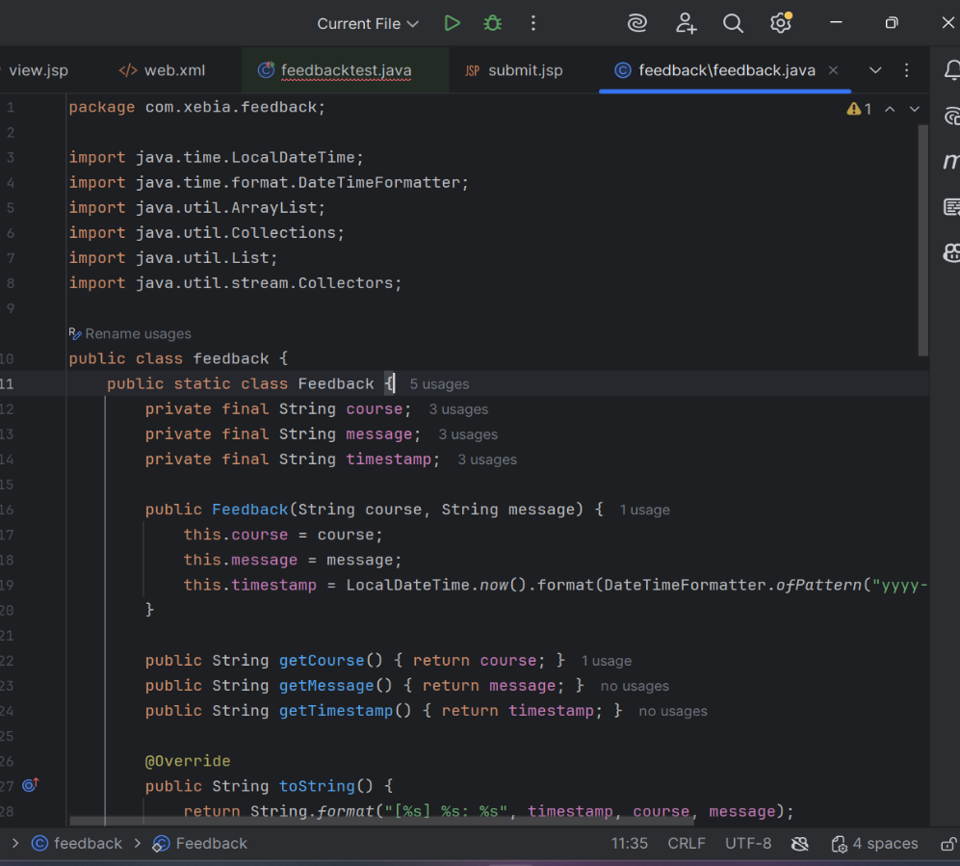
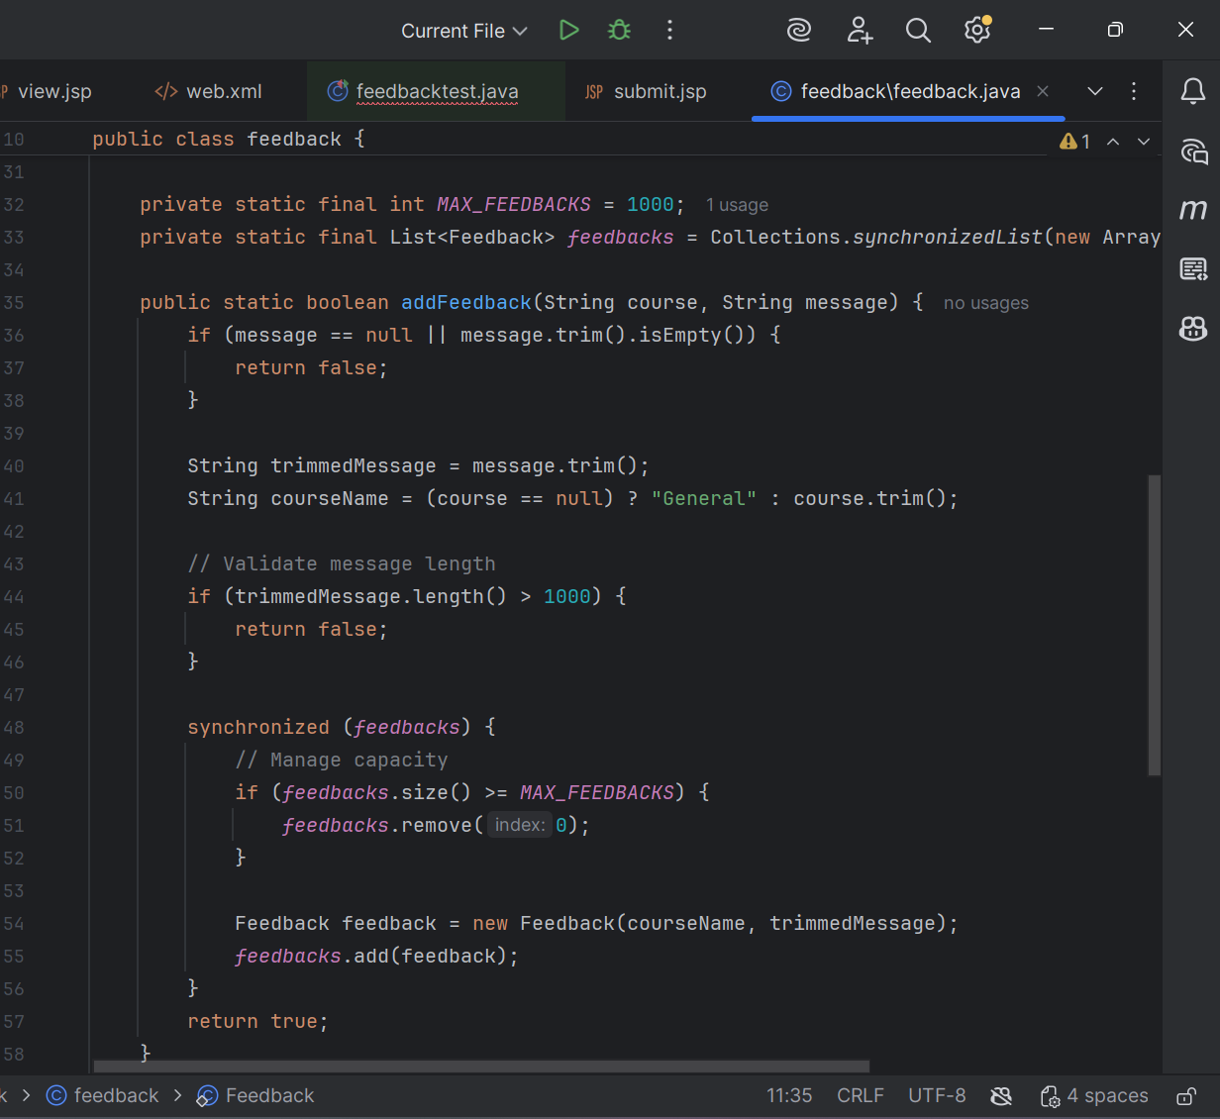
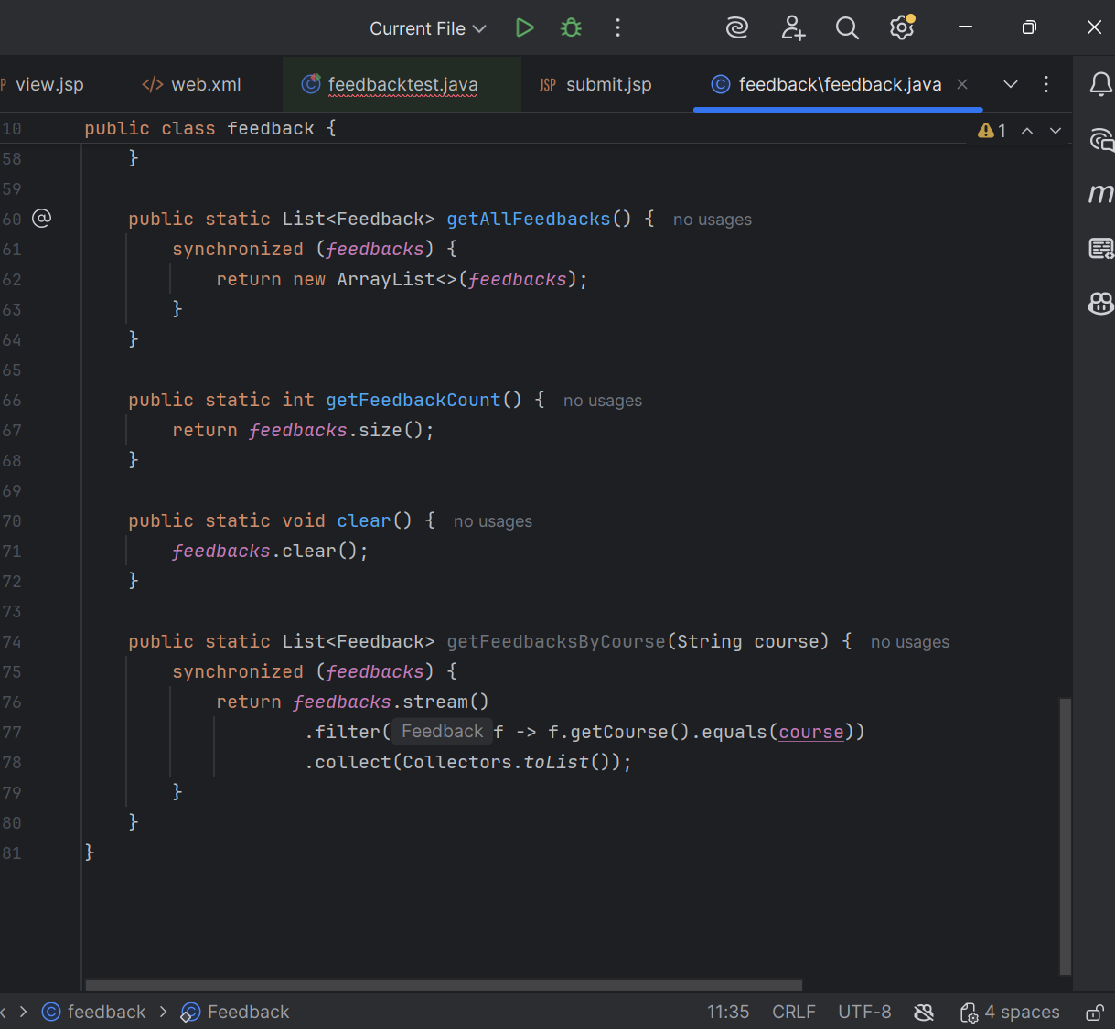

- Junit TESTING

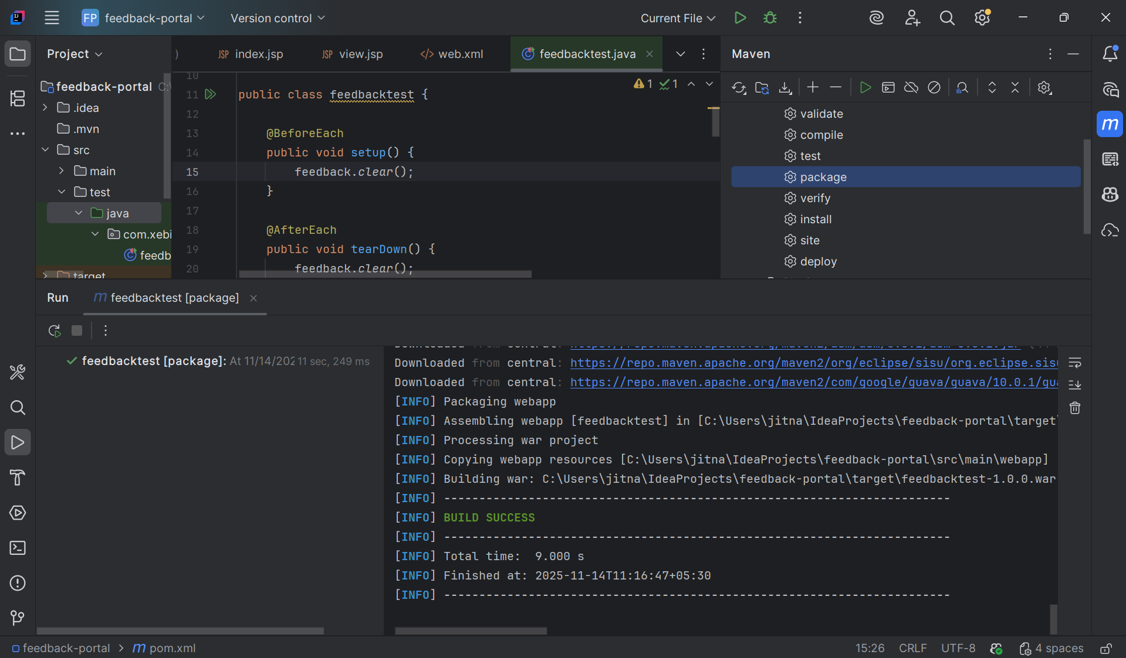
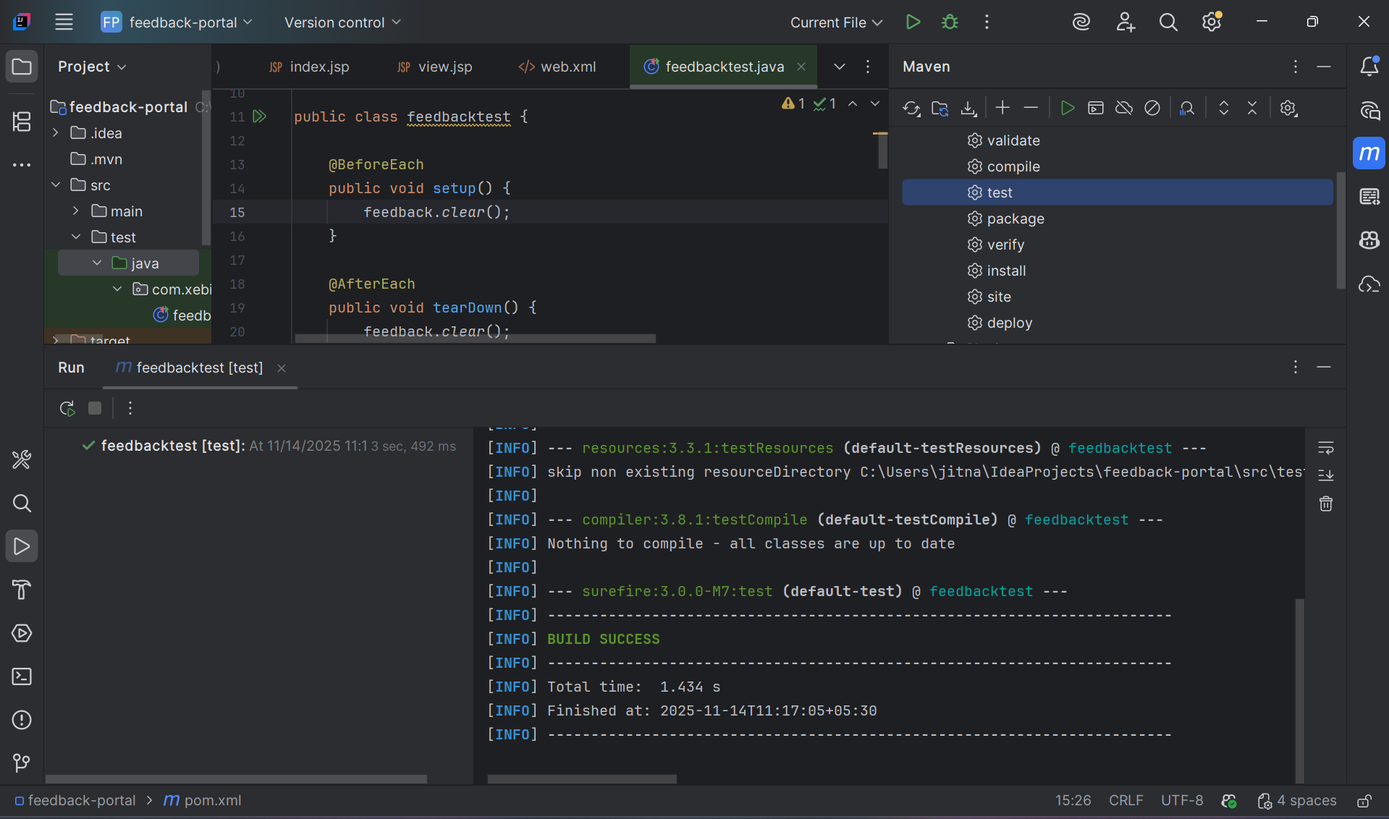
- JSP PAGES
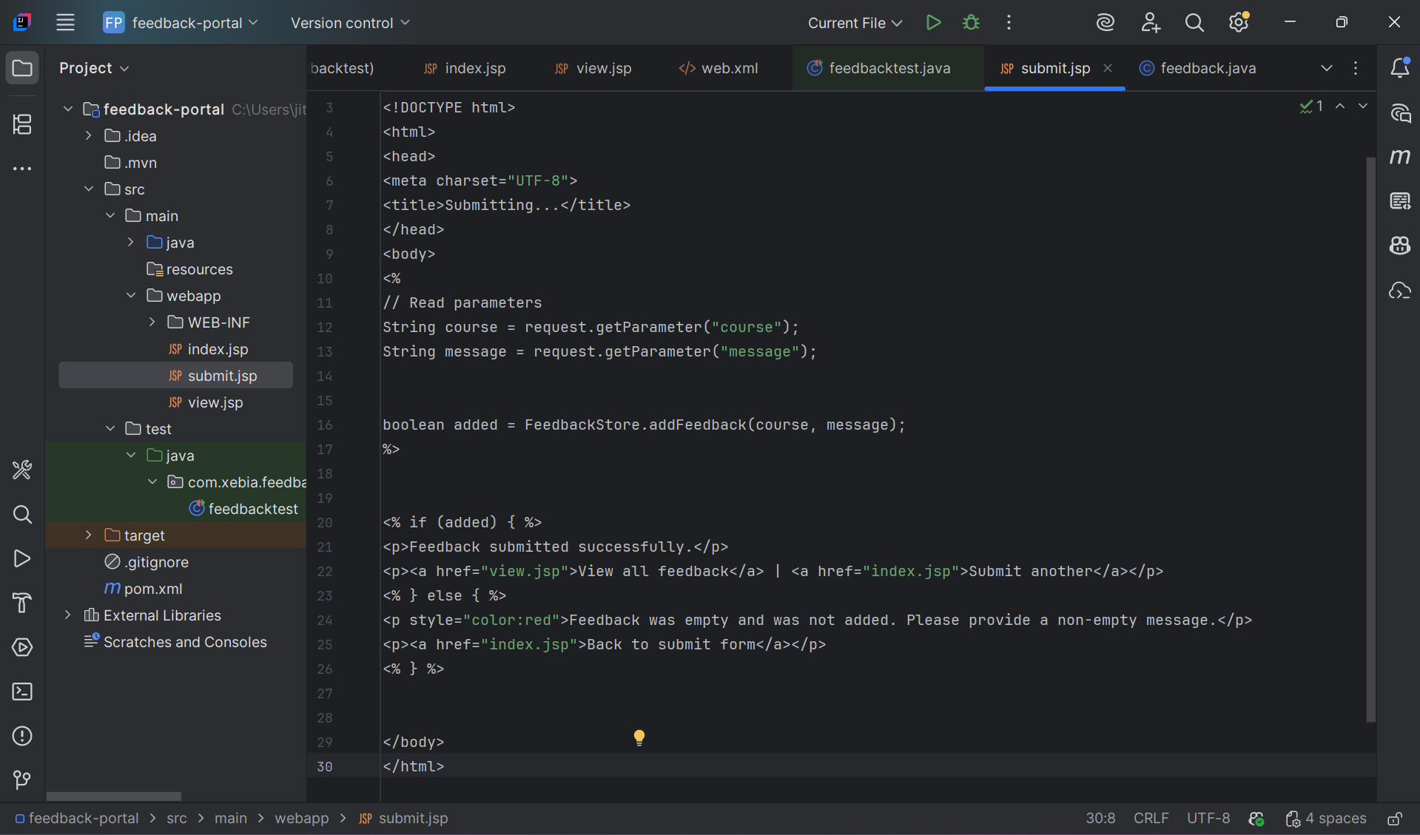
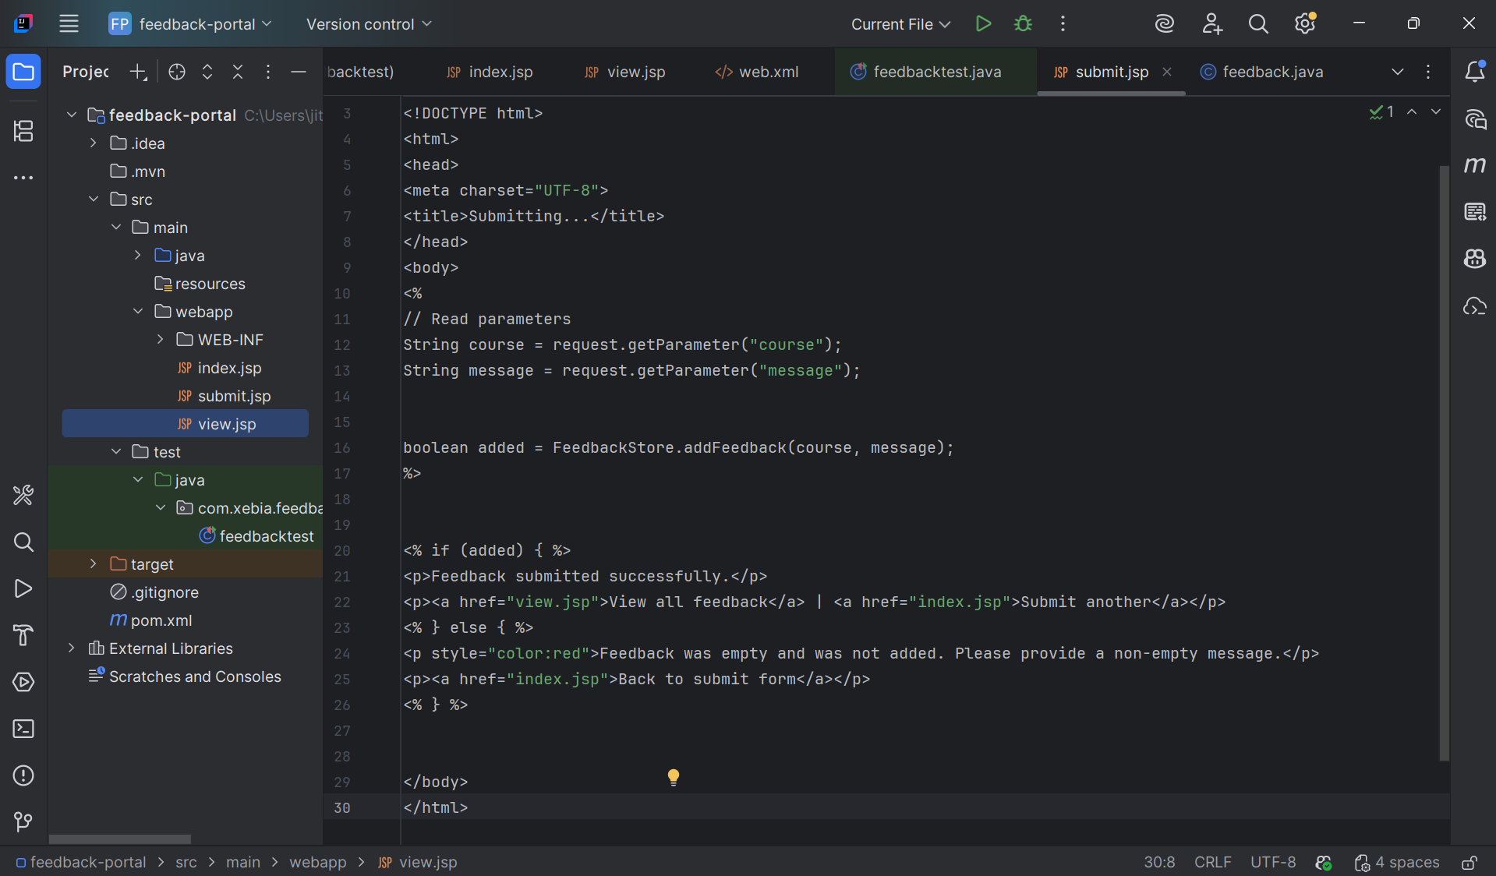

- Build and Deployment
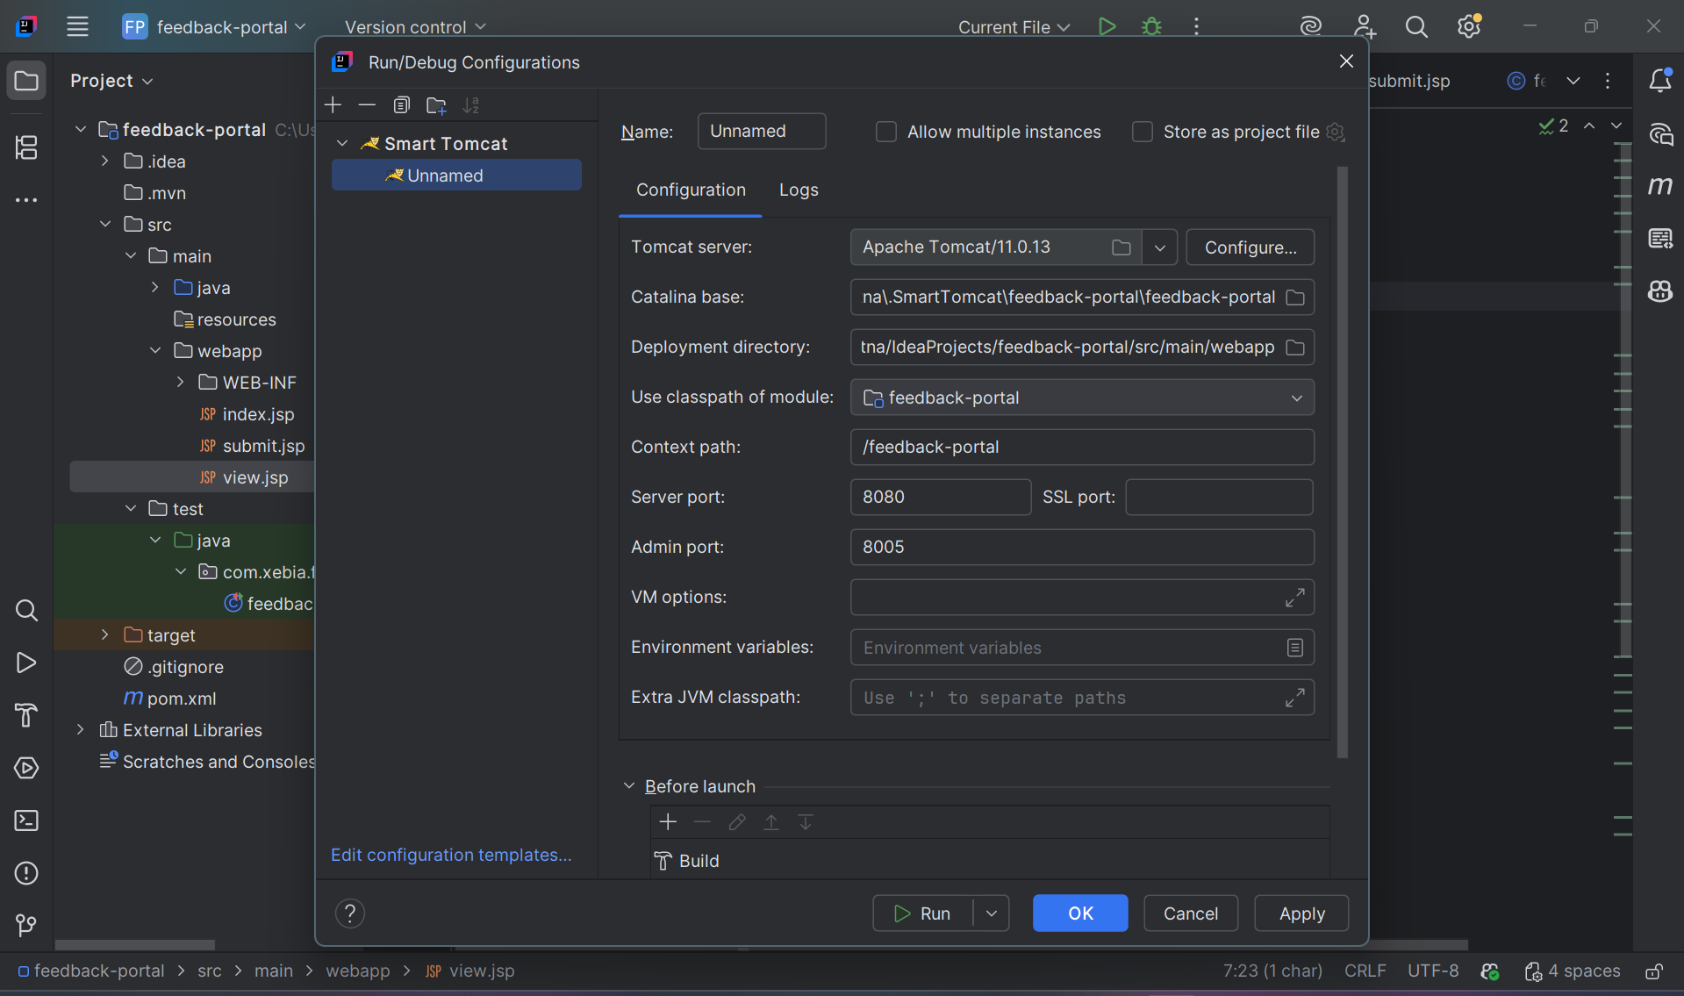
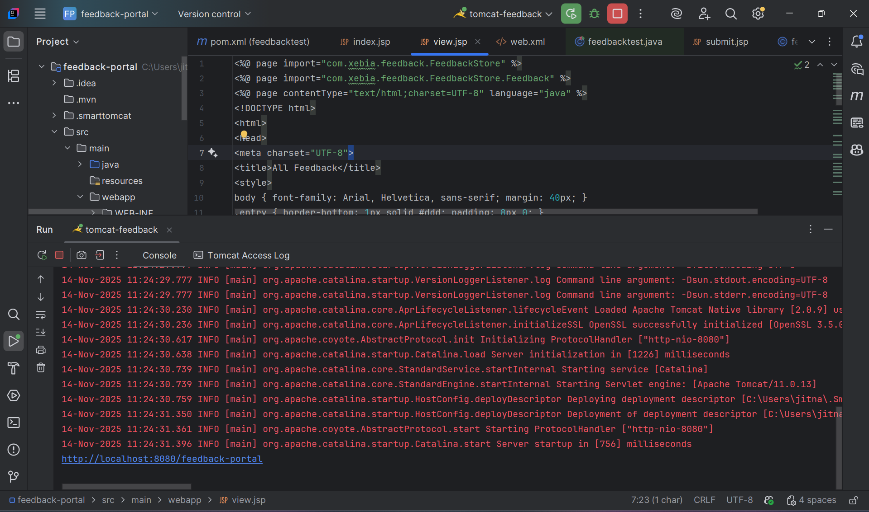

- Automation Validation

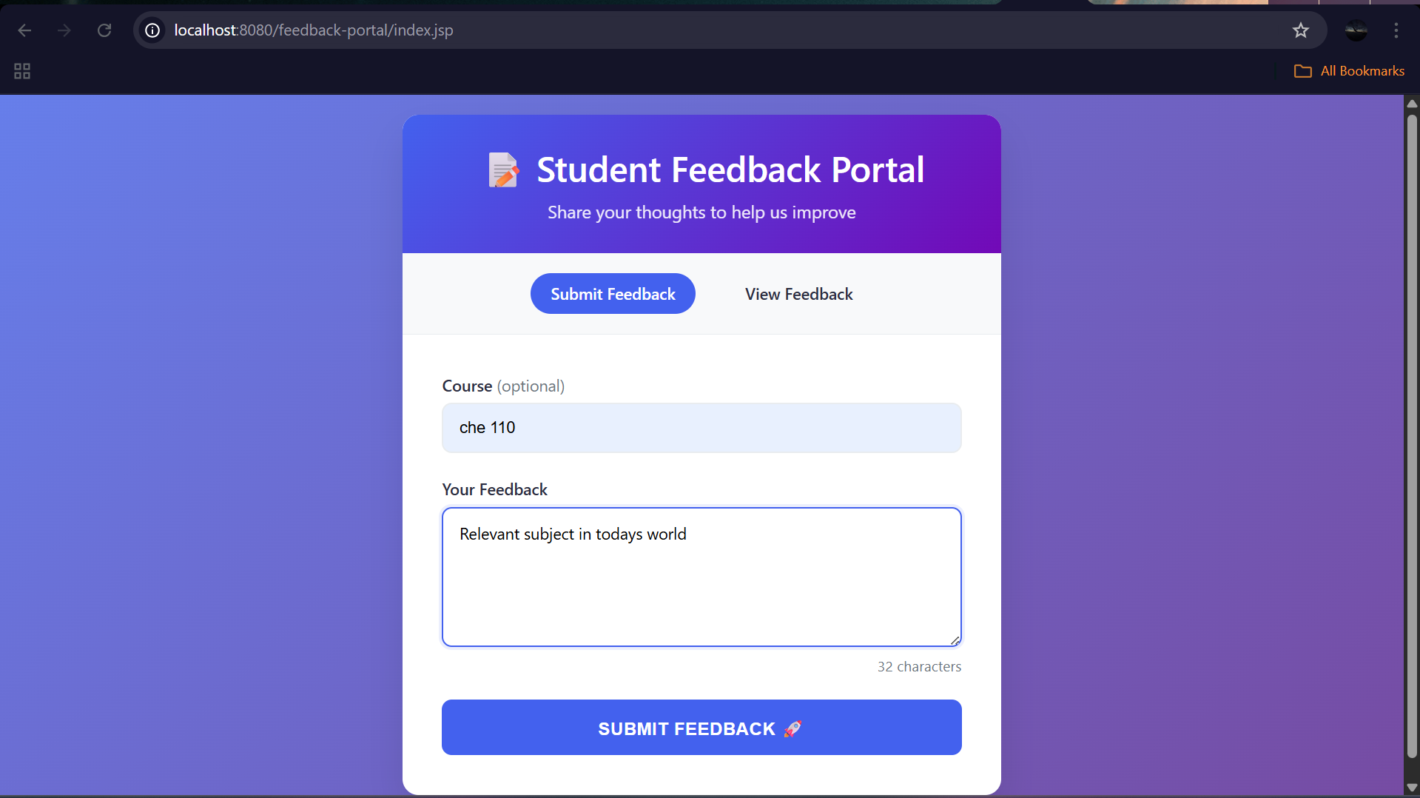
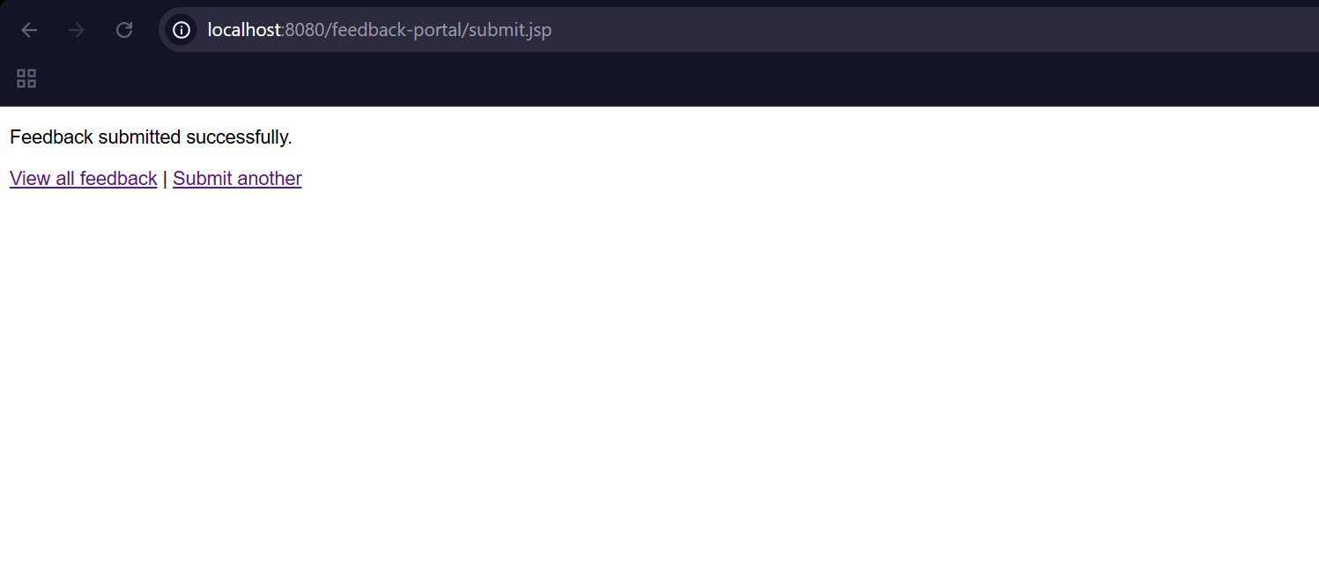
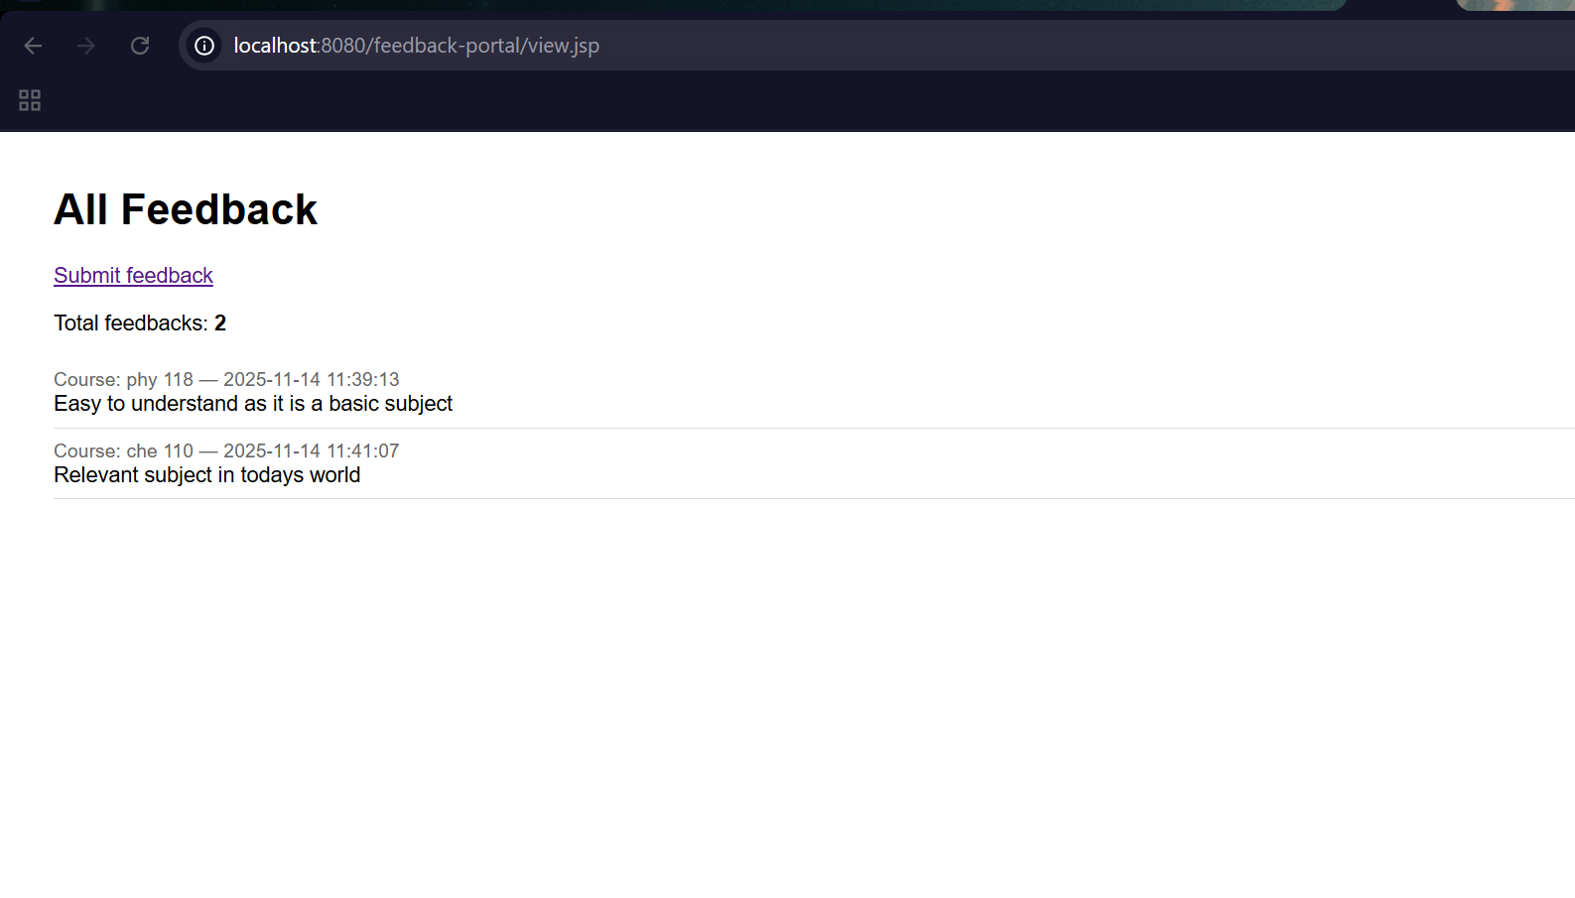
- Summary
Implemented Junit testing with the help of adding Junit dependency in pom.xml. Added servlet dependency, surefire plugins, Jupiter engine, Apache tomcat in pom.xml which helped in faster problem reduction.
Challenge faced: cannot include servlet in submit.jsp but was an insightful way. Website was working on opening, but actions had some errors but resolved it by finding errors in code.

